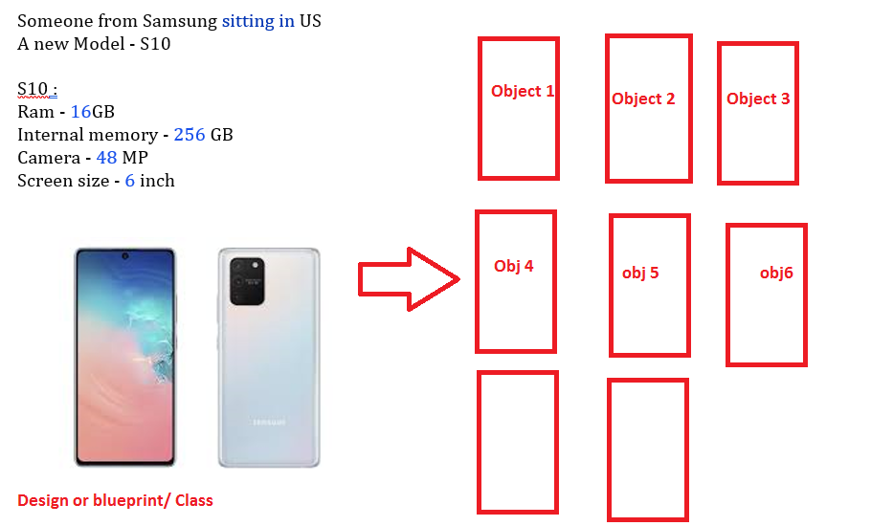

An Object is an instance of a class. We can consider a class like a blueprint or design while an object/instance is a copy of the class with actual Ram, internal memory, camera, screensize etc.

**A object should have**

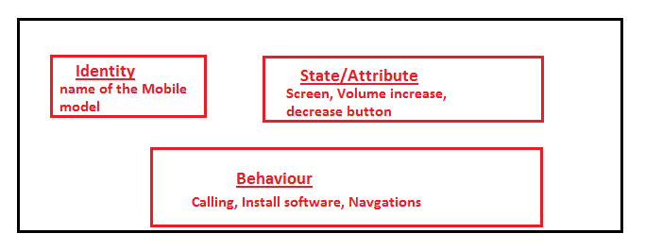

State: Screen, Volume increase -decrease button

Behaviour: Voice calling, Video calling, Install softwares, Do google map navigation : So behavior is nothing but a function - When this function comes into picture of a object oriented Programming in Python. **We will call this as Method**.

Itentity: a unique name